1. Resolve Merge Conflicts
- Create a merge conflict intentionally (two users editing the same line).
- Resolve the conflict and push the changes
- Initial Commit
- │
- ┌────┴────┐
- │ │
- user1 user2
- │ │
- Edit Edit
- same same
- line line
- │ │
- └────┬────┘
- │
- git merge
- │
- CONFLICT
- │
- Resolve
- │
- Commit
- │
- Push
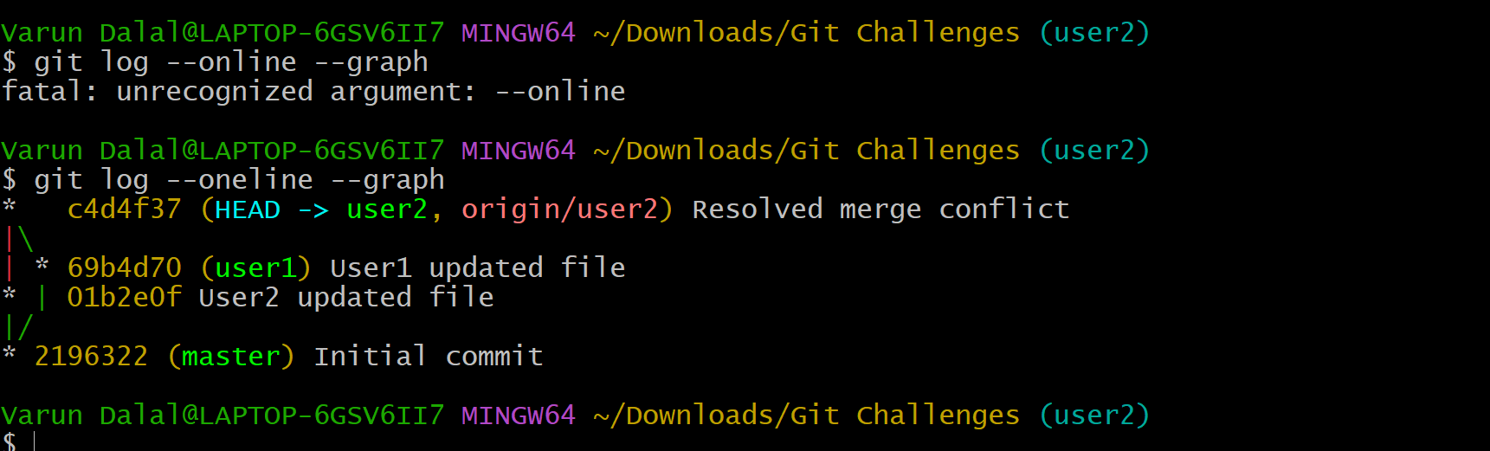

2. Recover Deleted Branch-
- Delete a local branch and then recover it using the reflog.

Create Branch
│
Commit Changes
│
Delete Branch
│
git reflog
│
Find Commit ID
│
Recreate Branch
│
Recovered Successfully
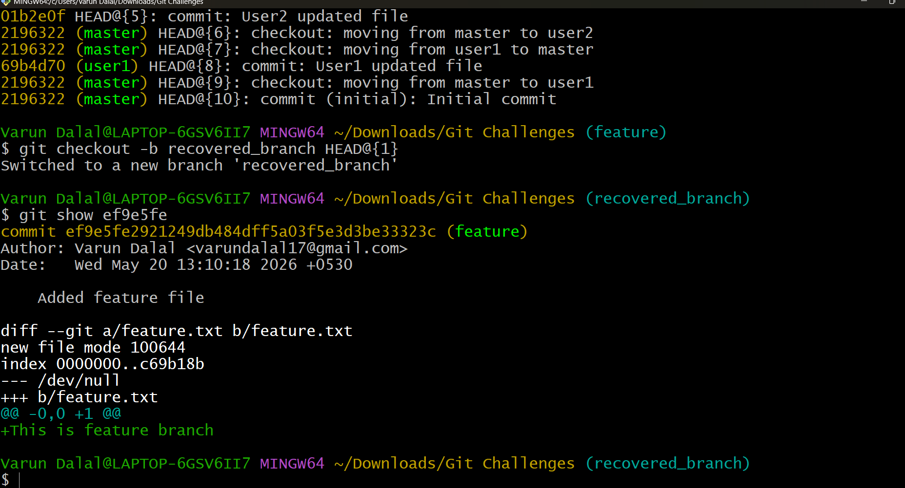

3. Undo Wrong Push
- Push a wrong commit to GitHub, then undo it without losing history
- 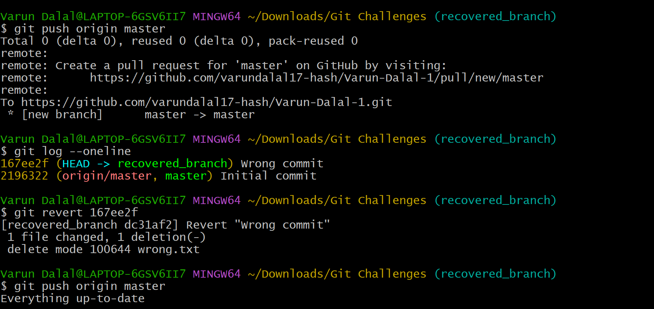
- Wrong Commit
- │
- git push
- │
- Mistake Found
- │
- git revert
- │
- New Revert Commit
- │
- git push
- │
- History Preserved

4. Make a commit, then add a missing file to it usinggit commit --amend
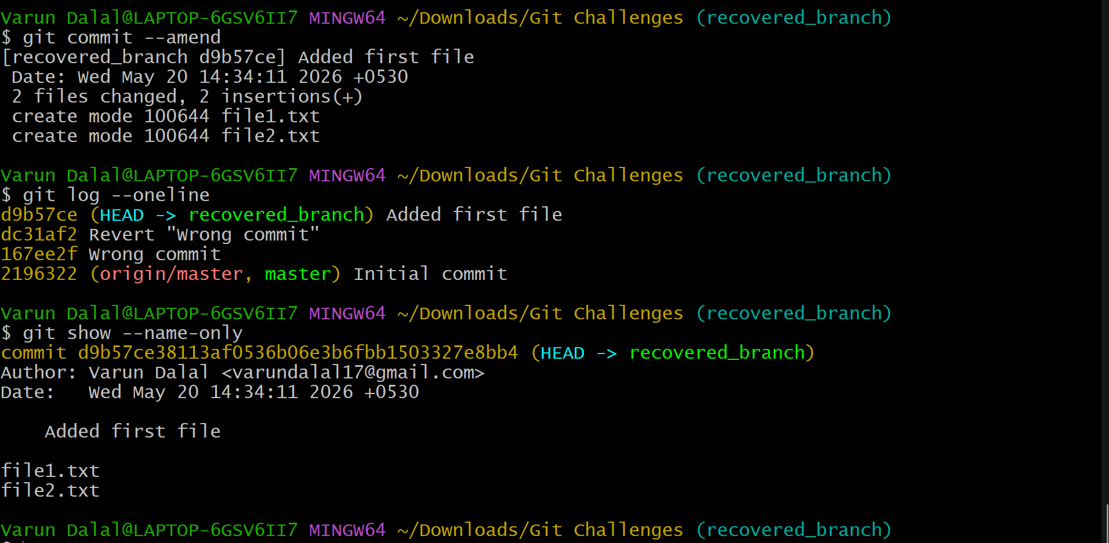
Create file1
│
Commit
│
Forgot file2
│
git add file2
│
git commit --amend
|
Previous commit updated

5. Take a specific commit from one branch and apply it to another branch
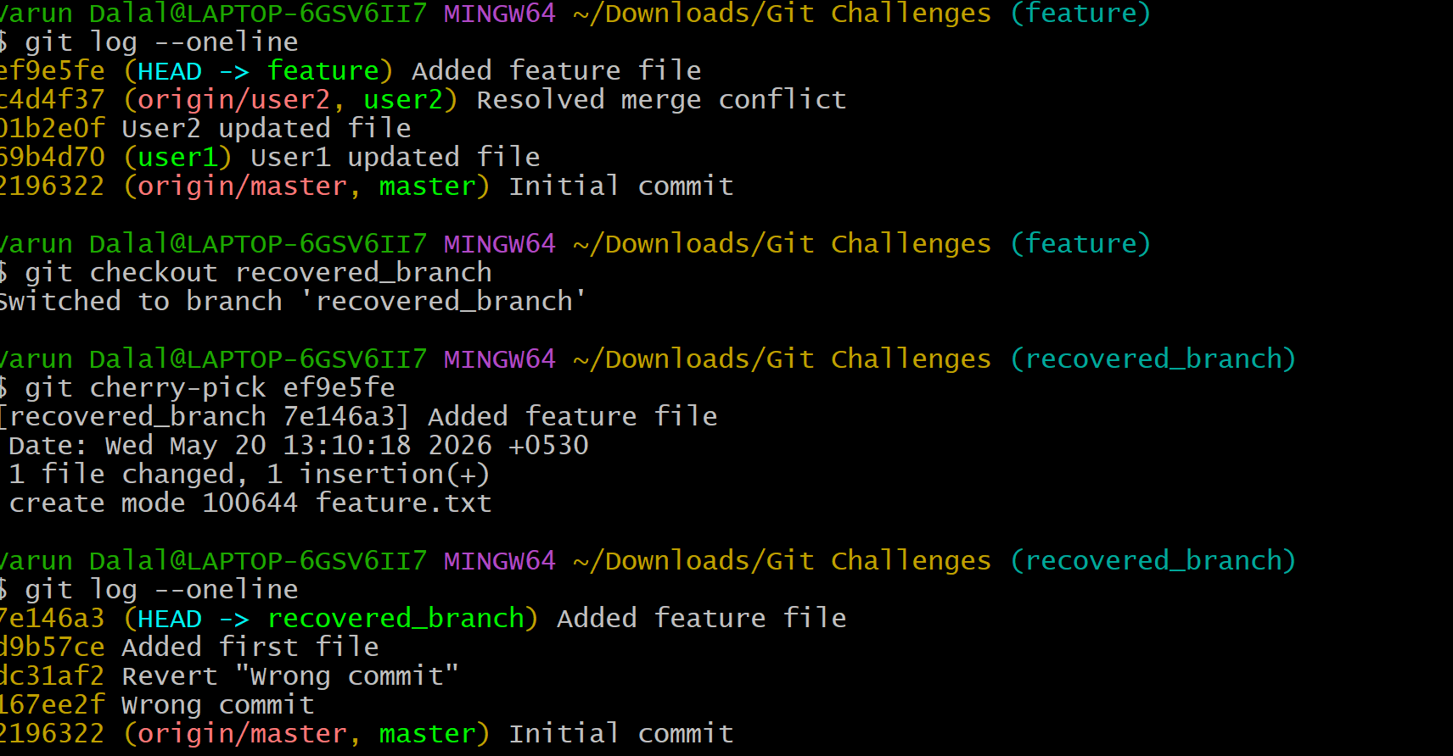
feature branch
│
ef9e5fe ← specific commit
│
└──────────────┐
↓
recovered_branch
│
git cherry-pick ef9e5fe
│
commit copied successfully

6. nteractive Rebase
- Reorder and squash multiple commits into a single clean commit

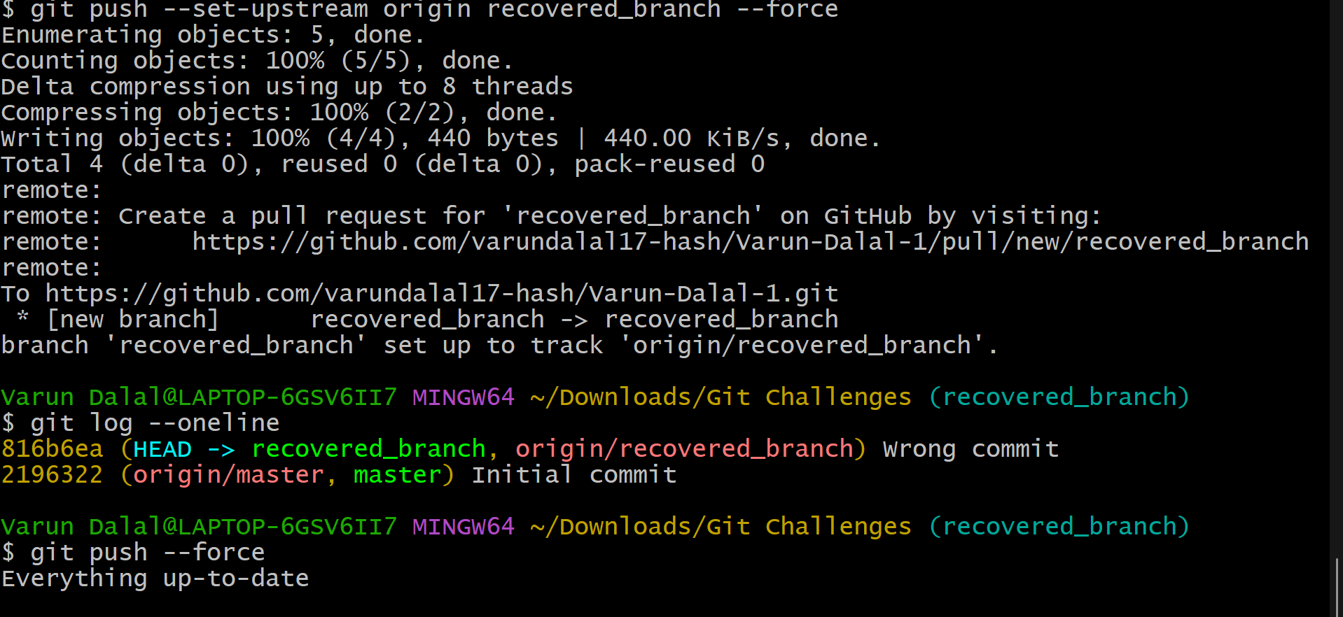
Commit1
Commit2
Commit3
│
git rebase -i HEAD~3
│
Reorder + squash
│
Single Clean Commit

7. Tagging & Release
- Create a version tag (v1.0), push it to GitHub, then delete and restore it.

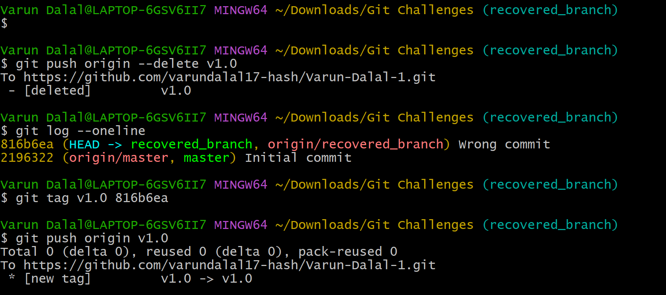
Create Tag
│
Push Tag
│
Delete Local Tag
│
Delete Remote Tag
│
Find Commit ID
│
Restore Tag
│
Push Again

8. Clone with Sparse Checkout
- Clone only a subdirectory of a repo using sparse checkout
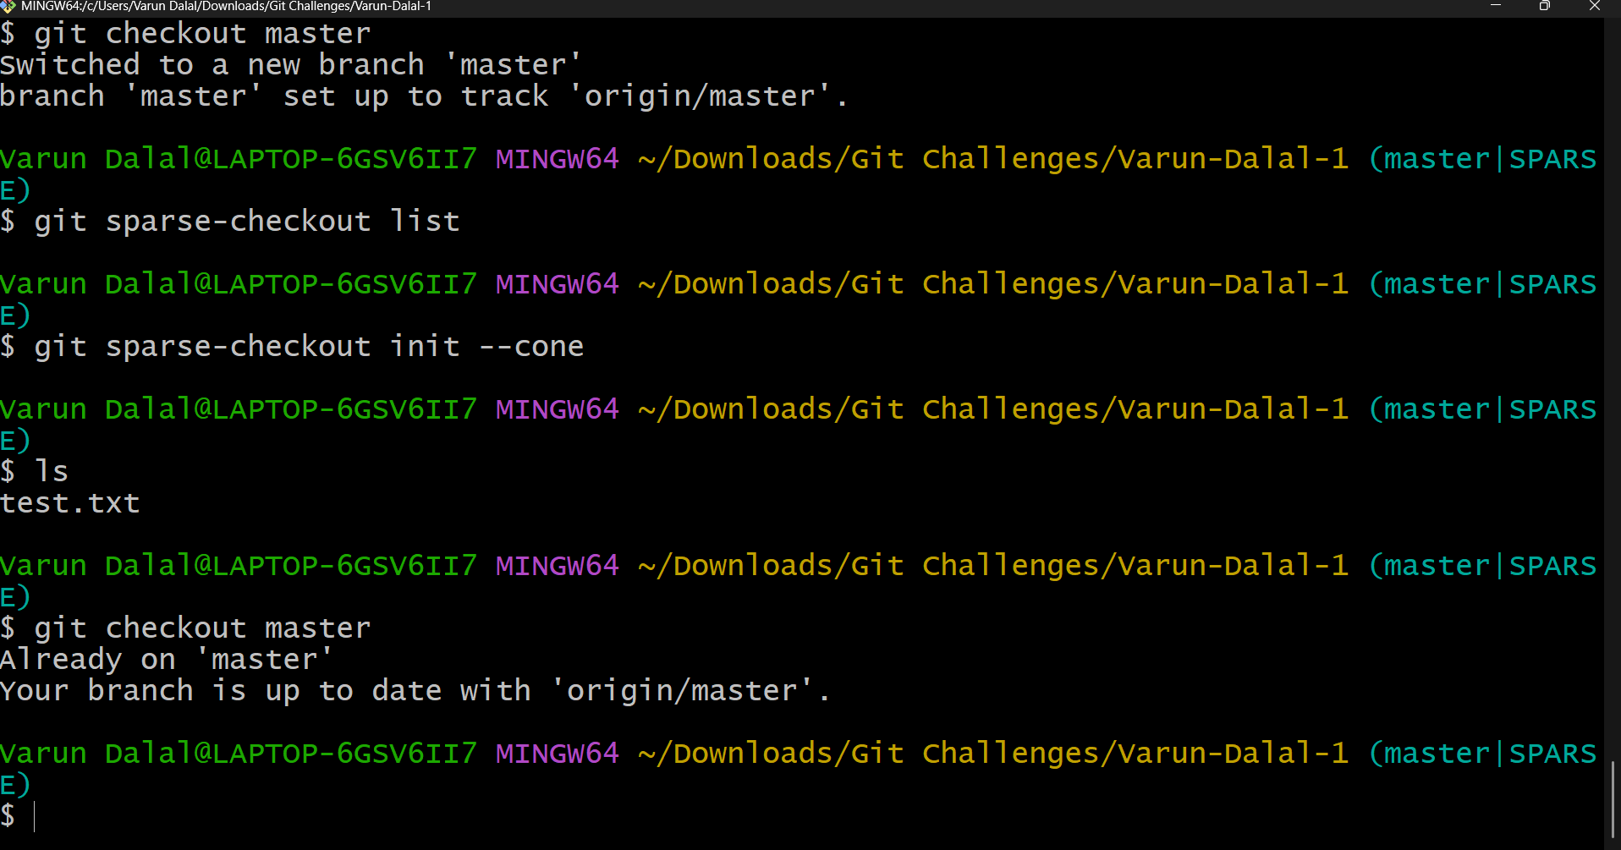
Clone Repo
│
Enable Sparse Checkout
│
Select Folder
│
Checkout Branch
│
Only Required Folder Downloaded

9. Reset vs Revert Challenge
Demonstrate the difference betweengit reset --hardandgit revertin a repo
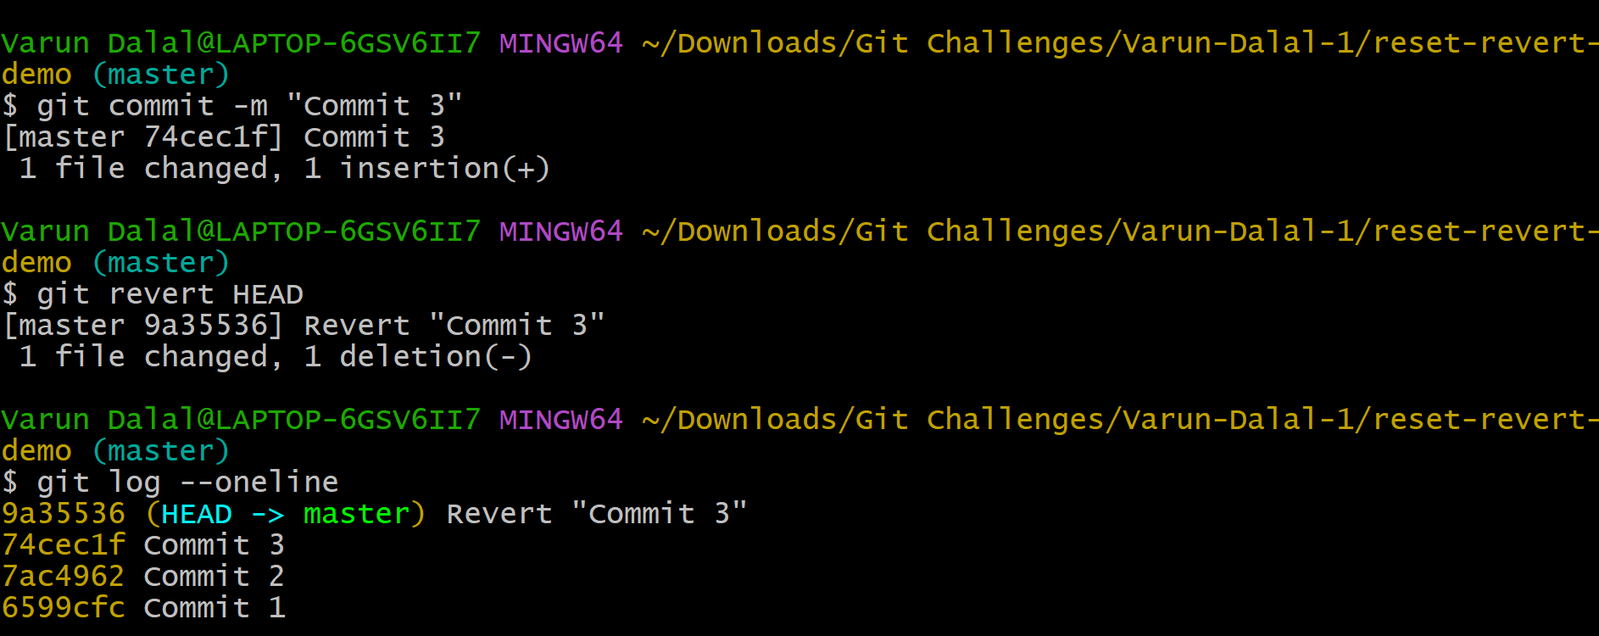
START
│
Commit1 → Commit2 → Commit3
│
┌───────────┴───────────┐
│ │
▼ ▼

git reset --hard git revert

│ │

Commit1 only Commit1 → Commit2
(history rewritten) → Commit3 → RevertCommit

│ │

Dangerous Safe for shared repos
after push

10. Detached HEAD Challenge
- Checkout a specific commit (detached HEAD state) and create a new branch from it.

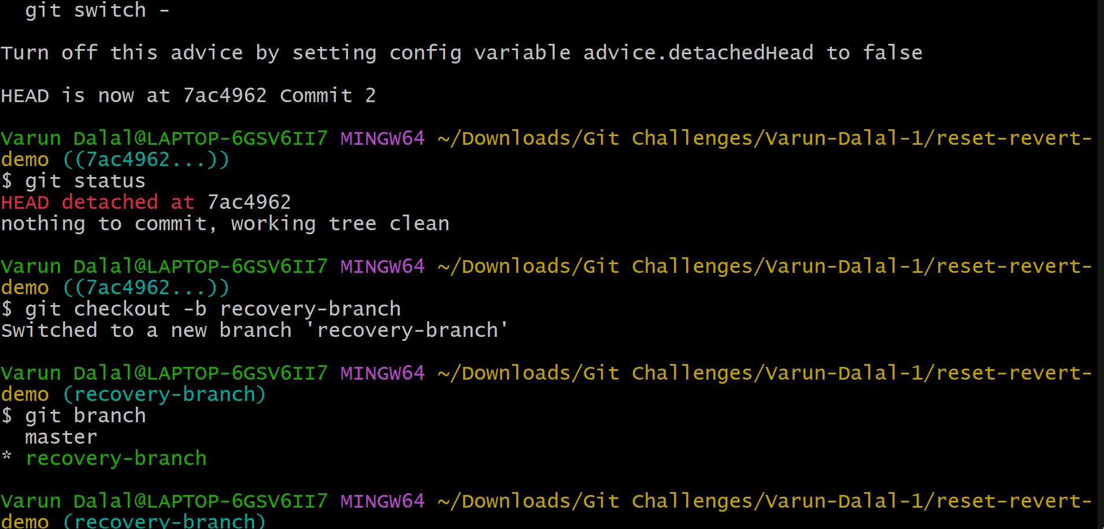
master
│
├── Commit A
├── Commit B
│ │
│ └── recovery-branch (HEAD)
│
└── Commit C

11. Git Hooks Challenge
- Configure apre-commithook to reject commits without a message format (e.g., must start withJIRA-XXX
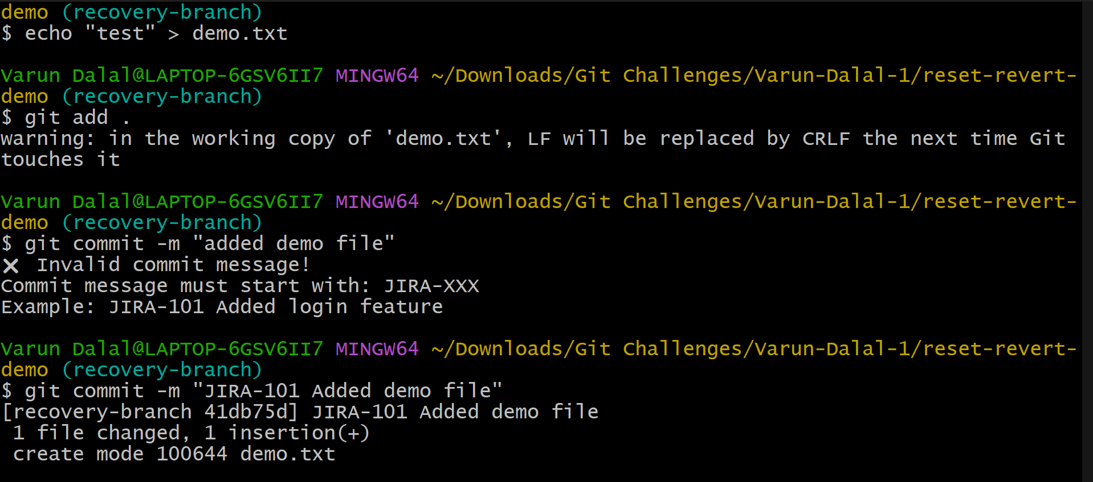
git commit
│
▼
commit-message hook
│
├── Valid format → Commit allowed ✅
│
└── Invalid format → Commit blocked ❌

12.
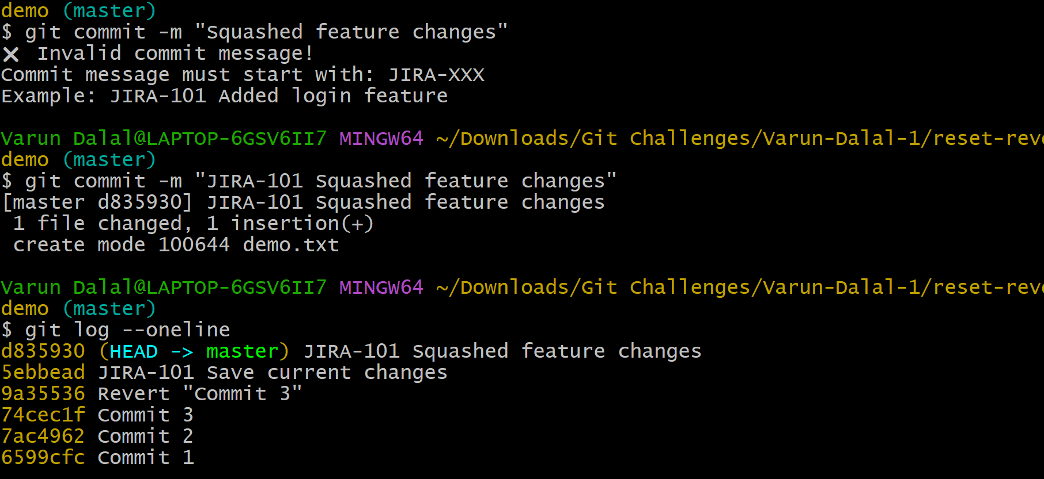
master
│
├── A
│
feature
├── B
├── C
└── D

git merge --squash feature

master
│
├── A
└── E ← Single Squashed Commit
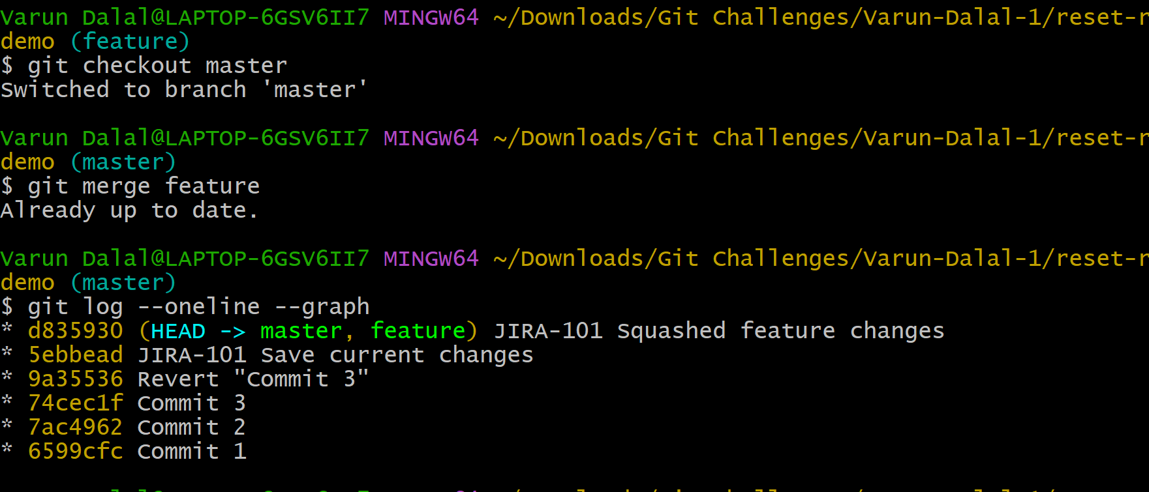
Before Rebase

master
│
├── A

feature
├── B
├── C
└── D

git rebase master

After Rebase

master
│
├── A
├── B
├── C
└── D

13. Fork & Pull Request Workflow
- Fork a repo, make a change, and submit a pull request to the original repo
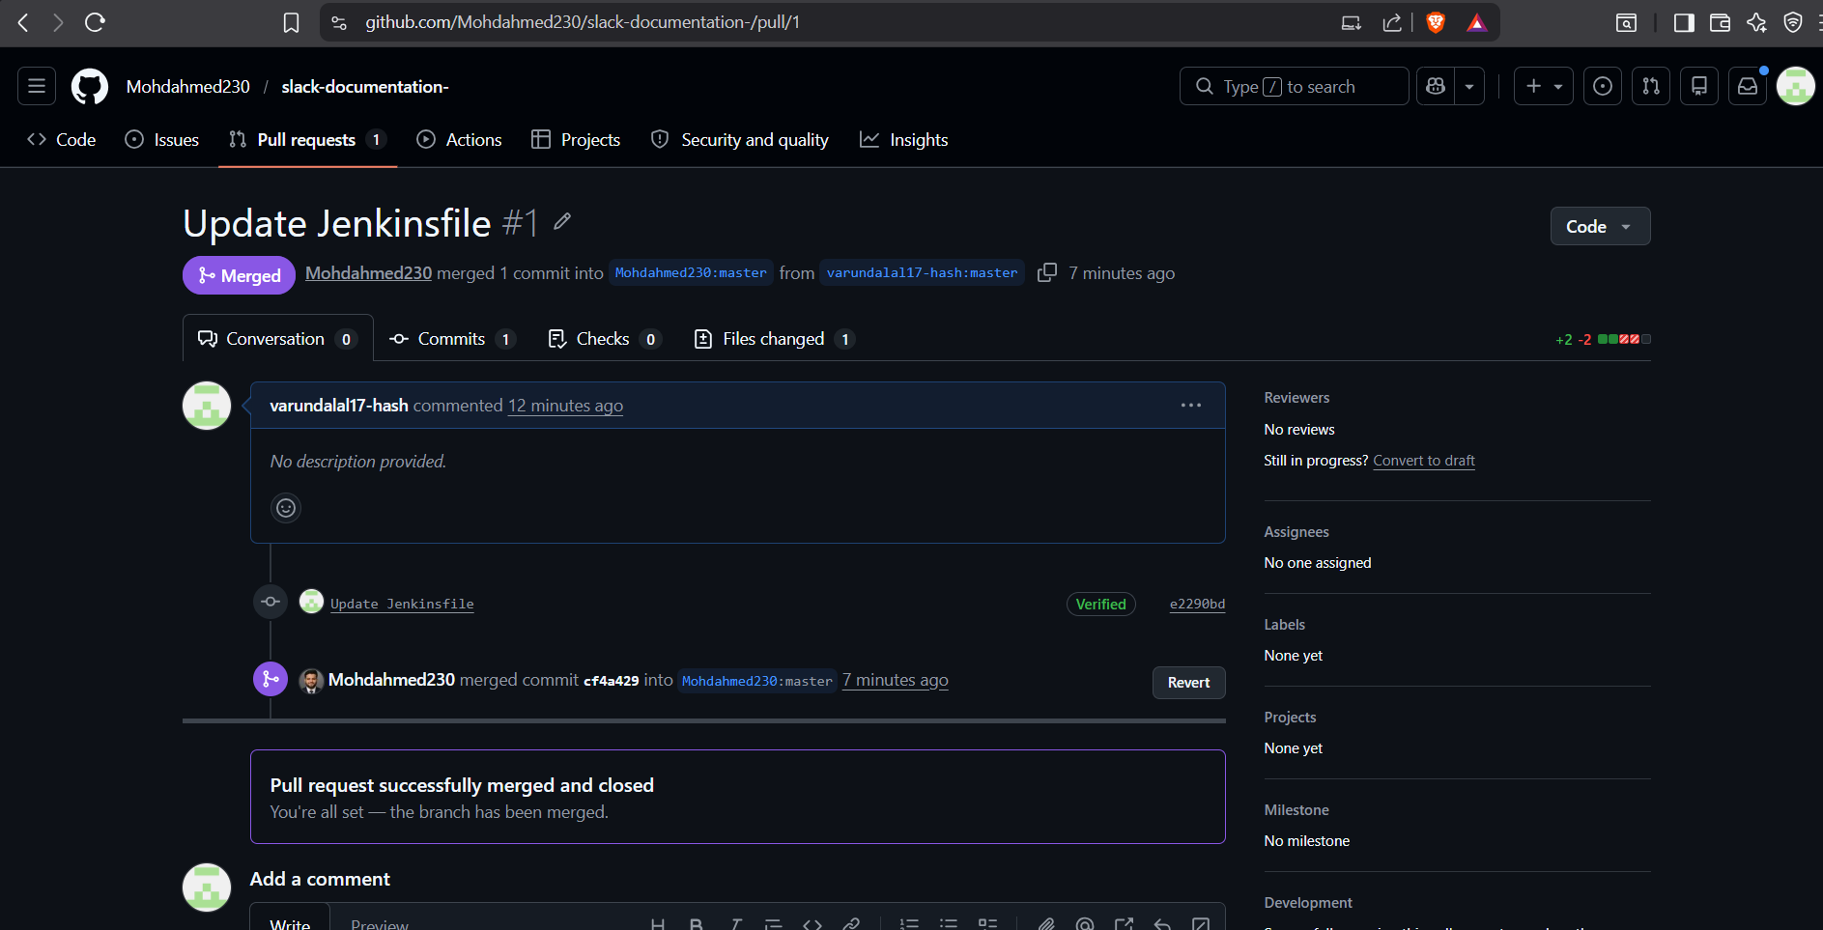
14. Recover Lost Commit
- Commit something, reset hard, and then recover it usinggit reflog.
